**Week 5**

**2. Microservices with API gateway**

**Microservices with Spring Boot 3 and Spring Cloud HandsOn**

**Creating Microservices for account and loan**

In this hands on exercises, we will create two microservices for a bank. One microservice for handing accounts and one for handling loans.

Each microservice will be a specific independent Spring RESTful Webservice maven project having it's own pom.xml. The only difference is that, instead of having both account and loan as a single application, it is split into two different applications. These webservices will be a simple service without any backend connectivity.

**Account Microservice**

**FILE STRUCTURE**

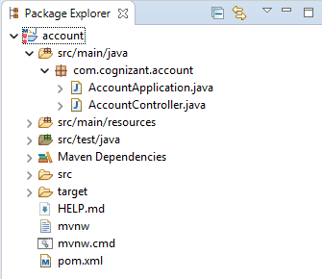

**CODE**

*D:\employeeid\microservices\account\src\main\java\com\cognizant\account\AccountController.java*

package com.cognizant.account;

import org.springframework.web.bind.annotation.*;

@RestController

@RequestMapping("/accounts")

public class AccountController {

    @GetMapping("/{number}")

    public Account getAccount(@PathVariable String number) {

        return new Account(number, "savings", 234343);

    }

}

class Account {

    private String number;

    private String type;

    private int balance;

    public Account(String number, String type, int balance) {

        this.number = number;

        this.type = type;

        this.balance = balance;

    }

    public String getNumber() { return number; }

    public String getType() { return type; }

    public int getBalance() { return balance; }

}

*D:\employeeid\microservices\account\src\main\java\com\cognizant\account\AccountApplication.java*

package com.cognizant.account;

import org.springframework.boot.SpringApplication;

import org.springframework.boot.autoconfigure.SpringBootApplication;

@SpringBootApplication

public class AccountApplication {

    public static void main(String[] args) {

        SpringApplication.run(AccountApplication.class, args);

    }

}

*D:\employeeid\microservices\account\pom.xml*

<?xml version="1.0" encoding="UTF-8"?>

<project xmlns="http://maven.apache.org/POM/4.0.0" xmlns:xsi="http://www.w3.org/2001/XMLSchema-instance"

    xsi:schemaLocation="http://maven.apache.org/POM/4.0.0 https://maven.apache.org/xsd/maven-4.0.0.xsd">

    <modelVersion>4.0.0</modelVersion>

    <parent>

        <groupId>org.springframework.boot</groupId>

        <artifactId>spring-boot-starter-parent</artifactId>

        <version>3.5.3</version>

        <relativePath/> <!-- lookup parent from repository -->

    </parent>

    <groupId>com.cognizant</groupId>

    <artifactId>account</artifactId>

    <version>0.0.1-SNAPSHOT</version>

    <name>account</name>

    <description>Demo project for Spring Boot</description>

    <url/>

    <licenses>

        <license/>

    </licenses>

    <developers>

        <developer/>

    </developers>

    <scm>

        <connection/>

        <developerConnection/>

        <tag/>

        <url/>

    </scm>

    <properties>

        <java.version>17</java.version>

    </properties>

    <dependencies>

        <dependency>

            <groupId>org.springframework.boot</groupId>

            <artifactId>spring-boot-starter-web</artifactId>

        </dependency>

        <dependency>

            <groupId>org.springframework.boot</groupId>

            <artifactId>spring-boot-devtools</artifactId>

            <scope>runtime</scope>

            <optional>true</optional>

        </dependency>

        <dependency>

            <groupId>org.springframework.boot</groupId>

            <artifactId>spring-boot-starter-test</artifactId>

            <scope>test</scope>

        </dependency>

    </dependencies>

    <build>

        <plugins>

            <plugin>

                <groupId>org.springframework.boot</groupId>

                <artifactId>spring-boot-maven-plugin</artifactId>

            </plugin>

        </plugins>

    </build>

</project>

*D:\employeeid\microservices\account\src\main\resources\application.properties*

spring.application.name=account

**OUTPUT**

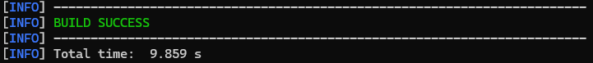

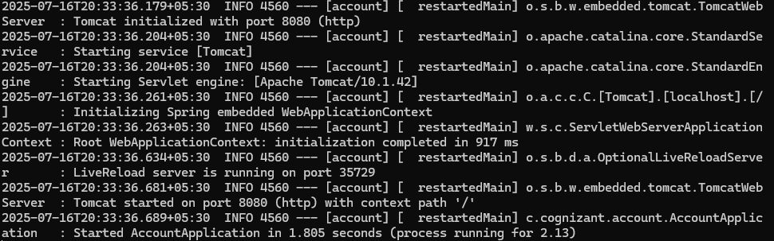

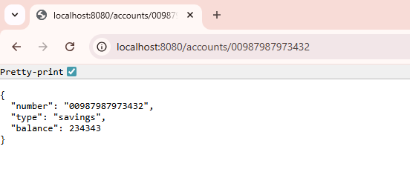

**Loan Microservice**

**FILE STRUCTURE**

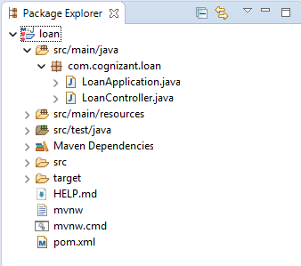

**CODE**

*D:\employeeid\microservices\loan\src\main\java\com\cognizant\loan\LoanController.java*

package com.cognizant.loan;

import org.springframework.web.bind.annotation.*;

@RestController

@RequestMapping("/loans")

public class LoanController {

    @GetMapping("/{number}")

    public Loan getLoan(@PathVariable String number) {

        return new Loan(number, "car", 400000, 3258, 18);

    }

}

class Loan {

    private String number;

    private String type;

    private int loan;

    private int emi;

    private int tenure;

    public Loan(String number, String type, int loan, int emi, int tenure) {

        this.number = number;

        this.type = type;

        this.loan = loan;

        this.emi = emi;

        this.tenure = tenure;

    }

    public String getNumber() { return number; }

    public String getType() { return type; }

    public int getLoan() { return loan; }

    public int getEmi() { return emi; }

    public int getTenure() { return tenure; }

}

*D:\employeeid\microservices\loan\src\main\java\com\cognizant\loan\LoanApplication.java*

package com.cognizant.loan;

import org.springframework.boot.SpringApplication;

import org.springframework.boot.autoconfigure.SpringBootApplication;

@SpringBootApplication

public class LoanApplication {

    public static void main(String[] args) {

        SpringApplication.run(LoanApplication.class, args);

    }

}

*D:\employeeid\microservices\loan\pom.xml*

<?xml version="1.0" encoding="UTF-8"?>

<project xmlns="http://maven.apache.org/POM/4.0.0" xmlns:xsi="http://www.w3.org/2001/XMLSchema-instance"

    xsi:schemaLocation="http://maven.apache.org/POM/4.0.0 https://maven.apache.org/xsd/maven-4.0.0.xsd">

    <modelVersion>4.0.0</modelVersion>

    <parent>

        <groupId>org.springframework.boot</groupId>

        <artifactId>spring-boot-starter-parent</artifactId>

        <version>3.5.3</version>

        <relativePath/> <!-- lookup parent from repository -->

    </parent>

    <groupId>com.cognizant</groupId>

    <artifactId>loan</artifactId>

    <version>0.0.1-SNAPSHOT</version>

    <name>loan</name>

    <description>Demo project for Spring Boot</description>

    <url/>

    <licenses>

        <license/>

    </licenses>

    <developers>

        <developer/>

    </developers>

    <scm>

        <connection/>

        <developerConnection/>

        <tag/>

        <url/>

    </scm>

    <properties>

        <java.version>17</java.version>

    </properties>

    <dependencies>

        <dependency>

            <groupId>org.springframework.boot</groupId>

            <artifactId>spring-boot-starter-web</artifactId>

        </dependency>

        <dependency>

            <groupId>org.springframework.boot</groupId>

            <artifactId>spring-boot-devtools</artifactId>

            <scope>runtime</scope>

            <optional>true</optional>

        </dependency>

        <dependency>

            <groupId>org.springframework.boot</groupId>

            <artifactId>spring-boot-starter-test</artifactId>

            <scope>test</scope>

        </dependency>

    </dependencies>

    <build>

        <plugins>

            <plugin>

                <groupId>org.springframework.boot</groupId>

                <artifactId>spring-boot-maven-plugin</artifactId>

            </plugin>

        </plugins>

    </build>

</project>

*D:\employeeid\microservices\loan\src\main\resources\application.properties*

spring.application.name=loan

server.port=8081

**OUTPUT**

